**Tour Outline.**

After our test ride up the museum hill, we will head to one of the highest points in Agnes, looking out to the north to see 1770’s Round Head where you will eventually explore and the Hills out to the west we will be riding through.

The first 1 hour is all about cruising around and taking in the sights, we probably won’t be stopping so absorb what you see. We will cruise slow to take in the environment and see what is around and ride fast when we need to be fast. If you have something in particular that you would like to see, let me know at check in time, so we can plan it in. 😊

**During our ride through the hills keep an eye out for:**

**Many Fun Mailboxes, 31 Power Poles covered in Art, Wildlife, Local Farms (there is 2), Farm Stalls, Cool Local Business you may wanna check out later, lots of lovely rural properties.**

**See what you normally wouldn’t see, in the backstreets where the locals live and things we get up to in this rural community off the main streets.**

**Spot Australian Wildlife 😊**

1770 was discovered in the year 1770

James Cook landed the endeavour ship in May 1770, coming from Botany Bay in Sydney. 1770 was the first landfall in the quest discovering Queensland with 12 other landfalls following. Lots of parks, suburbs, street names and themes here are based around the discovery story.

These men encountered our local aboriginal people known as the Mooroni Tribe apart of the Gureng Nation, who are still here and active today. They have been here 60,000 years and the story is told, some now share the royal blood line



Bustard bay light house was built in 1867, (almost 100 years after discovery an amongst the oldest buildings here.)

The first European settlers arrived here is 1878, you can see their burial in the main beach carpark under the fig tree, across the road from the first building built in Agnes, now the Tree Motel.

The populations currently is approx. 6000 people.

We have 1 public primary school, 1 Christan Collage from prep – 12 and no high school. It’s a 45 min bus trip each way for our high school kids.

We are the last surf beach heading north or the first surf beach heading south.

We frequently see sharks, whales, dolphins, turtles and coral mess in the waters.

**Fun Facts**

**You will get a surprise when you look in your review mirror and see the hills behind you**

**See The Views**

**From Above to Below!’**

**]bn**

**\\\\hj**

Starting Point

We will ride out to and along this line of hills.

1770 Headland, (round head)

**Either** explore the marina or explore the esplanade? You choose & let me know?

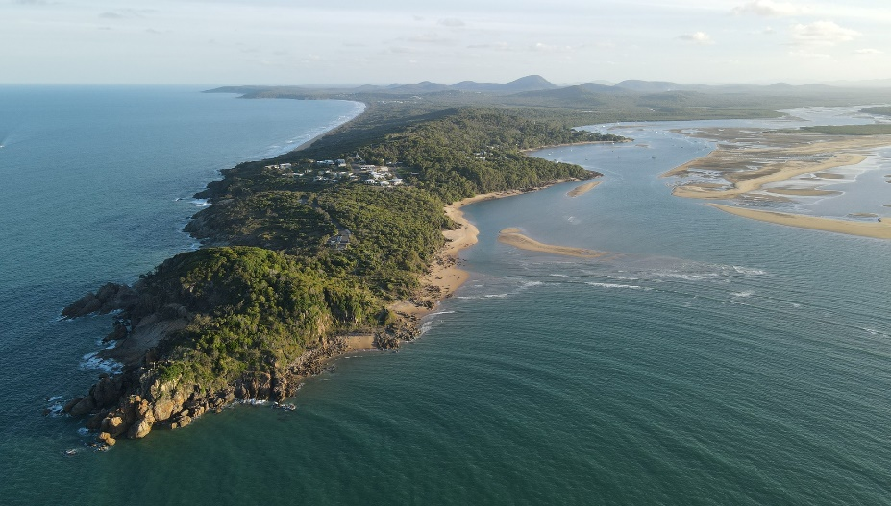

In the second hour, we will head to 1770 seeing the marina, esplanade, 2 of the headland lookouts and some free time to walk the 3 short trails over the headland.

**Watch for Dolphins at the 1770 Headland**

**Explore the Headland**

**Spot the Light House on the other side of the Bay.**

Welcome and thank you again for being a part of our scooter tour and supporting our little business, below is some important road rules reminders for your safety on the road, hand ques, things you will see today, some fun facts about our region and what you will see today😊

**All Australian Road rules apply, we consider your safety priority, we will be riding to road and weather conditions.**

* During our ride you must comply with all road rules to travel safely with your guide.
* We travel in a lot of 80km zones, our scooter will be going mostly between 45km – 60km people will overtake us. You as a road user have the use of the road as any other motorists and other motorists should be overtaking with compliance to road safety.
* Stay calm and stick to the left and follow my lead, I will allow cars to overtake us, by indicating left, slowing down and moving to the left.
* I will regularly check in with your condition, thumbs up if all is good, thumbs down if you need to stop to ask questions such as scooter operations, scooter faults, first aid or amenities.
* Always use your indicators correctly to comply with road rules for other motorist safety. Please turn off once turned.
* You must drive a safe distance behind the vehicle travelling in front of you.
* Be aware of the physical road conditions and always choose a safe line to ride.
* Do your best to avoid pot poles, road faults, dirt or gravel and always ride to the road’s conditions.
* By the group staying alert and aware to their surroundings, helps each rider to adequately adhere road safety to avoid hazards such as large pot holes, wildlife, roadworks, road spills or road damages.
* Hang your helmet gently on the helmet hook.
* Look your handlebars & take the scooter key with you when leaving the scooter.
* If you get lost from the group, keep coming towards 1770 and enjoy your free time, we are heading to the headland or meet us back at the scooter shop no later then the end of the tour time.



**Feel free to leave a Review on our google profile or on any of our social platforms.**

**Fill out our questionnaire, to help us improve our scooter tours, please scan here.**

**Find and Follow our Socials Below, Tag or mention us to share the love**

**Find your tour photos here,**

**Let me know if you prefer not to be in the photos.**

**Or Here**